EXPERIMENT NO. 2
TITLE: Process control system calls: The demonstration of fork, execv and wait system calls along with zombie and orphan states.
AIM:
a. Implement the C program in which main program accepts the integers to be sorted. Main program uses the fork system call to create a new process called a child process. Parent process sorts the integers using merge sort and waits for child process using wait system call to sort the integers using quick sort. Also demonstrate zombie and orphan states.
b. Implement the C program in which main program accepts an integer array. Main program uses the fork system call to create a new process called a child process. Parent process sorts an integer array and passes the sorted array to child process through the command line arguments of execv system call. The child process uses execv system call to load new program that uses this sorted array for performing the binary search to search the particular item in the array.
Prerequisite: C
Theory:
1. Introduction
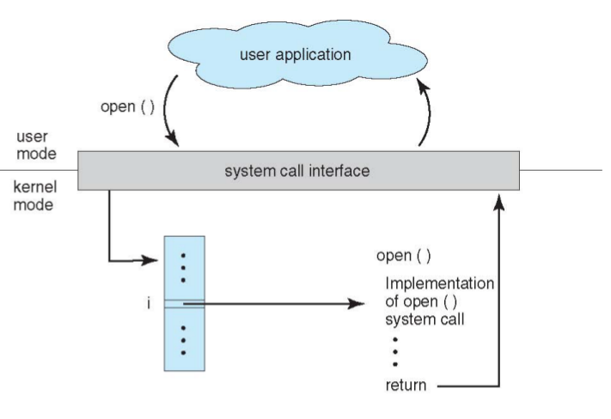
System Calls are Programming interface to the services provided by the OS. Typically written in a high-level language (C or C++) , Mostly accessed by programs via a high-level Application Program Interface (API) rather than direct system call use , Three most common APIs are Win32 API for Windows, POSIX API for POSIX-based systems (including virtually all versions of UNIX, Linux, and Mac OS X), and Java API for the Java virtual machine (JVM).

Figure:API – System Call – OS Relationship
The system call provides an interface to the operating system services.
Application developers often do not have direct access to the system calls, but can access them through an application programming interface (API). The functions that are included in the API invoke the actual system calls. By using the API, certain benefits can be gained:
- Portability: as long a system supports an API, any program using that API can compile and run.
- Ease of Use: using the API can be significantly easier then using the actual system call.

What is Process ?
- A program in execution
- An instance of a program running on a computer
- The entity that can be assigned to and executed on a processor
- A unit of activity characterized by the execution of a sequence of instructions, a current state, and an associated set of system instructions
Process Elements
- Program code (possibly shared)
- A set of data
- A number of attributes describing the state of the process
Process Control Block
- Contains the process elements
- Created and manage by the operating system
- Allows support for multiple processes
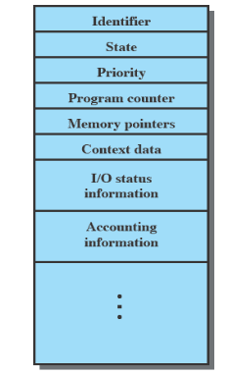

Figure1.1:Process Control Block

Process Creation:
At system boot time, one user level process is created. In Unix, this process is called init. In Windows, it is the System Idle Process. This process is the parent or grand-parent of all other processes.
New Child Processes are created by another process (the Parent Process).
1. fork() system call:System call fork() is used to create processes. It takes no arguments and returns a process ID. The purpose of fork() is to create a new process, which becomes the child process of the caller. After a new child process is created, both processes will execute the next instruction following the fork() system call. Therefore, we have to distinguish the parent from the child. This can be done by testing the returned value of fork():

- If fork() returns a negative value, the creation of a child process was unsuccessful.
- fork() returns a zero to the newly created child process.
- fork() returns a positive value, the process ID of the child process, to the parent. The returned process ID is of type pid_t defined in sys/types.h. Normally, the process ID is an integer. Moreover, a process can use function getpid() to retrieve the process ID assigned to this process.
Therefore, after the system call to fork(), a simple test can tell which process is the child. Unix will make an exact copy of the parent's address space and give it to the child. Therefore, the parent and child processes have separate address spaces.
If the call to fork() is executed successfully, Unix will
- make two identical copies of address spaces, one for the parent and the other for the child.
- Both processes will start their execution at the next statement following the fork() call. In this case, both processes will start their execution at the assignment statement as shown below:
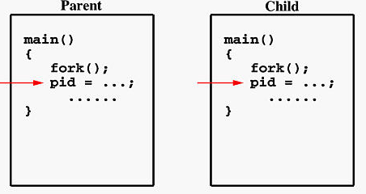

Both processes start their execution right after the system call fork(). Since both processes have identical but separate address spaces, those variables initialized before the fork() call have the same values in both address spaces. Since every process has its own address space, any modifications will be independent of the others. In other words, if the parent changes the value of its variable, the modification will only affect the variable in the parent process's address space. Other address spaces created by fork() calls will not be affected even though they have identical variable names.
When the main program executes fork(), an identical copy of its address space, including the program and all data, is created. System call fork() returns the child process ID to the parent and returns 0 to the child process. The following figure shows that in both address spaces there is a variable pid. The one in the parent receives the child's process ID 3456 and the one in the child receives 0.
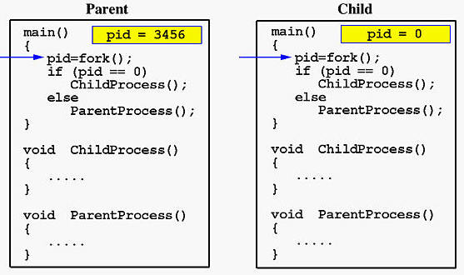

Now both programs (i.e., the parent and child) will execute independent of each other starting at the next statement.
wait() and waitpid:
#include <sys/types.h>
#include <sys/wait.h>
pid_t wait(int *statloc);
- Suspends calling process until child has finished. Returns the process ID of the terminated child if ok, -1 on error.
- statloc can be (int *)0 or a variable which will be bound to status information about a child
- A child exits when its parent is not currently executing wait()the child becomes a zombie
- Orphan process: Parent exits while child is in execution.
- Getpid() and getppid() can be used to obtain process id and parent process id
- Ps -f f or ps -e or ps -l can be used to see the process table
The exec() System Call:
The exec family of functions replace the current process image with a new process image. The new image shall be constructed from a regular, executable file called the new process image file. There shall be no return from a successful exec, because the calling process image is overlaid by the new process image.Calling one of the exec() family will terminate the currently running program and starts executing a new one which is specified in the parameters of exec in the context of the existing process. The process id is not changed.
int execl( const char *path, const char *arg, ...);
int execlp( const char *file, const char *arg, ...);
int execle( const char *path, const char *arg , ..., char * const envp[]);
int execv( const char *path, char *const argv[]);
int execvp( const char *file, char *const argv[]);
The naming convention: exec*
'l' indicates a list arrangement (a series of null terminated arguments)
'v' indicate the array or vector arrangement (like the argv structure).
'e' indicates the programmer will construct (in the array/vector format) and pass their own environment variable list
'p' indicates the current PATH string should be used when the system searches for executable files.

PARAMETERS
Path:Specifies the path name of the new process image file.
file:Is used to construct a path name that identifies the new process image file. If it contains a slash character, the argument is used as the path name for this file. Otherwise, the path prefix for this file is obtained by a search of the directories in the environment variable PATH. If PATH is not set, the current directory is searched.
arg0, ..., argn:Point to null-terminated character strings. These strings constitute the argument list for the new process image. The list is terminated by a NULL pointer. The argument arg0 should point to a file name that is associated with the process being started by the exec() function.
argv:Is the argument list for the new process image. This should contain an array of pointers to character strings, and the array should be terminated by a NULL pointer. The value in argv[0] should point to a file name that is associated with the process being started by the exec() function.
envp:Specifies the environment for the new process image. This should contain an array of pointers to character strings, and the array should be terminated by a NULL pointer.
Steps for programming:
Assignment 2(a)
- Use of fork() and wait() system call.
- Parent process sorts the numbers using merge sort
- Child process: Quick Sort
Assignment 2b:
Write the code for
- Accept and sort the numbers
- Convert the sorted numbers to string for passing to binary
- search program using exec().
- Create a child process using fork() or vfork().
- In child process i.e. pid = 0 call execve() with executable filename of binary search program, string array containing numbers to be passed and environment for execution
- Lets name this file as parent.c Write another program
- Copy the argument vector.
- Convert the sting to number form
- Perform binary search over the numbers.
- Save this as child.c
- Compile both the codes independently
- gcc -o p parent.c
- gcc -o c child.c
- Ensure that execve first argument is executable name of child
- process.
OUTPUT:
Assignment 2a: Demonstration of fork, wait system calls along with zombie and orphan states.
Assignment 2b:
- Demonstration of execv
- Parent process: sorts the data.
- Child process: performs binary search

PART A

#include<stdio.h>
#include<unistd.h>
#include<sys/types.h>
#include<sys/wait.h>

void quickSort(int [],int ,int );
int partition(int [],int ,int );

void mergeSort(int [],int ,int );
void merge(int [],int ,int ,int ,int );

int main()
{
int i,j,n;
int *status=NULL;
int arr[30];

printf("\nEnter the number of elements:");
scanf("%d",&n);

for(i=0;i<n;i++)
{
scanf("%d",&arr[i]);
}
pid_t pid;
pid=fork();

if(pid==0)
{
printf("\n\t This is child process. ");
printf("\n\t My process id is : %d", getpid());
printf("\n\t My Parent process id is : %d", getppid());
quickSort(arr,0,n-1);
printf("\nQuicksort");
for(i=0;i<n;i++)
printf(" %d",arr[i]);
printf("\n\n");
}
else
{

printf("\n\n\t Parent process resumed after the execution of child process with PID %d", pid);
printf("\n\t My process id is : %d", getpid());
printf("\n\t My Parent process id is : %d", getppid());
mergeSort(arr,0,n-1);
printf("\nMergesort:");
for(i=0;i<n;i++)
printf(" %d",arr[i]);
printf("\n\n");
pid=wait(status);

}

}

void quickSort(int arr[],int low,int high)
{
int j;
if(low<high)
{
j=partition(arr,low,high);
quickSort(arr,low,j-1);
quickSort(arr,j+1,high);
}
}

int partition(int arr[],int low,int high)
{
int i,j,temp,pivot;
pivot=arr[low];
i=low;
j=high+1;

do
{
do
i++;
while(arr[i]<pivot && i<=high);
do
j--;
while(arr[j]>pivot);

if(i<j)
{
temp=arr[i];
arr[i]=arr[j];
arr[j]=temp;
}
}
while(i<j);

arr[low]=arr[j];
arr[j]=pivot;

return(j);
}

void mergeSort(int arr[],int low,int high)
{
int mid;
if(low<high)
{
mid=(low+high)/2;
mergeSort(arr,low,mid);
mergeSort(arr,mid+1,high);
merge(arr,low,mid,mid+1,high);
}

}

void merge(int arr[],int i1,int j1,int i2,int j2)
{
int temp[50];
int i,j,k;
i=i1;
j=i2;
k=0;

while(i<=j1 && j<=j2)
{
if(arr[i]<arr[j])
temp[k++]=arr[i++];
else
temp[k++]=arr[j++];
}
while(i<=j1)
temp[k++]=arr[i++];
while(j<=j2)
temp[k++]=arr[j++];

for(i=i1,j=0;i<=j2;i++,j++)
arr[i]=temp[j];
}

PART B

Main.c

#include <sys/types.h>
#include <sys/wait.h>
#include <stdio.h>
#include <stdlib.h>
#include <unistd.h>
void quicksort(int [10],int,int);
void main()
{
int pid, ppid, a[10], size, i;
char *argv[12];
for(i=0; i<12; i++)
{
argv[i] = (char *) malloc(20);
}
printf("\nIn the main of parent process. \nMy process-id is %d.", getpid());
printf("\n\nEnter the number of elements in the array: \n");
scanf("%d", &size);
printf("Enter %d elements: ", size);
for(i=0;i<size;i++)
scanf("%d",&a[i]);
quicksort(a, 0, size-1);
printf("Sorted elements: ");
for(i=0;i<size;i++)
printf(" %d",a[i]);
printf("\nPARENT: I am calling my child for searching now!\n");
printf("-------------------------------------------------------");
pid = vfork(); //Here, the child process is created and both
//simultaneously. fork() returns 0 to child process and pid of
//child to parent process. So, if int
//pid here is 0, it means we
//are in child process and if any
//+ve no., then in parent process
//where the +ve no. is the child's pid

if(pid==0)
{
printf("CHILD: In child process. My process-id is %d.\n", getpid());
printf("CHILD: My parent's process-id is %d.\n\n", getppid());
printf("\n CHILD: Calling searching using execv now. Will be overlayed!\n");
for(i=0; i<size; i++){
sprintf(argv[i+1], "%d", a[i]);
}
argv[0] = "./child";
argv[size+2] = NULL;
execv("./child", argv);
printf("Error");
printf("\nCHILD: I am dying now\n");
printf("-------------------------------------------------------\n\n");
}
else if (pid>0)
{
system("wait");
printf("\nPARENT: I am dying now\n");
printf("-------------------------------------------------------");
printf("\n\n.");
}
}
void quicksort(int a[10],int first,int last)
{
int pivot,j,temp,i;
if(first<last)
{
pivot=first;
i=first;
j=last;
while(i<j){
while(a[i]<=a[pivot]&&i<last)
i++; while(a[j]>a[pivot])
j--;
if(i<j){
temp=a[i];
a[i]=a[j];
a[j]=temp;
}
}
temp=a[pivot];
a[pivot]=a[j];
a[j]=temp;
quicksort(a,first,j-1);
quicksort(a,j+1,last);
}
}

Child.c

#include <sys/types.h>
#include <sys/wait.h>
#include <stdio.h>
#include <stdlib.h>
#include <unistd.h>
void binarysearch(long int [10], int n);
void main(int argc, char *argv[],char *envp[])
{
int i, n=0;
long ret[10];
for(i=1; argv[i]!=NULL; i++)
{
ret[i] = strtol(argv[i], NULL, 10);
n++;
}
printf("SEARCH: In second child process. My process-id is %d.\n", getpid());
printf("SEARCH: My parent's process-id is %d.\n\n", getppid());
binarysearch(ret, n);
}
void binarysearch(long int a[10], int n)
{
int c, first, last, middle, search;

printf("Enter value to search: \n");
scanf("%d",&search);
printf("\n\n=================In Binary Search Program===================\n");
first = 0;
last = n - 1;
middle = (first+last)/2;
while( first <= last )
{
if ( a[middle] < search )
first = middle + 1;
else if ( a[middle] == search )
{
printf("%d found at location %d.\n", search, middle);
break;}
else
last = middle - 1;
middle = (first + last)/2;
}
if ( first > last )
printf("%d is not present in the list.\n", search);
}

